

VM IO PROFILING DOCUMENT

Synopsis: This document details the various methods to finalize the IO profiling for VM in our environment.

Segment: Data Centre Engineering and Managed Services – Storage

Authors: Santhana Ramasamy

Contributors: Robert Bauer

Document Version: V.1.0
Date: 30 April 2013
Document Status: Active

CONFIDENTIAL INFORMATION
This document contains information proprietary to Thomson Reuters and may not be reproduced, disclosed or used in whole or part without express permission of Thomson Reuters.

© Thomson Reuters 2009
Contents
1 Introduction 3
1.1 Management Summary 3
1.2 Document Scope 3
1.3 References 3
1.4 Change History 3
1.5 Distribution List 3
1.6 Glossary 3
2 Performance Terminology 4
3 VIRTUALIZATION FILER LAYOUT ………………………………………………………….4
4. VM workload overview 5
5 Multiple Datapoints 6
6 IMPORTANCE OF IO PROFILING 7
6.1 Scenario 1 8
7 BEST PRACTICES 10
8 RECOMMENDATIONS ……………………………………………………………...…11
8.1.1 Virtualization storage big rules ......................................................11
9 CHALLENGES NEEDS TO BE ADDRESSED………………………………….…………...13
9.1.1 How to monitor the IOps utilization for per datastore ? 13
9.1.2 what happens if we reached this limit ? 13
10 Conclusions 14

Introduction

Management Summary
This document explains the importance of having a standard in number of datastores and number of VM per datastore to avoid any performance issues in future and to maintain the stability , capacity of the filer (storage machine) . This is just an overview and is derived using the existing data available in our environment. This will provide the final recommended counts like ,
a. No of Datastores per filer head
b. No of VM’s per datastore

Document Scope
Reviewer of this document was expected to have a basic knowledge about the storage, Virtualization technology to understand the idea behind this effort.

References
 | Document | Version | Date | Author
1 | Performance analysis – Netapp | 01 |  | Netapp Engineering

Change History
Ver | Date | Author | Key Changes
0.1  0.2  0.3  0.4  0.5  0.6 | 30-April-2013  02-May-2013  04-June-2013  04-June-2013  04-June-2013  04-June-2013 | Santhana Ramasamy  Santhana Ramasamy  Santhana Ramasamy  Robert Bauer  Robert/Santhana  Robert/Santhana | Initial draft for comment.  VM workload overview  Performance details updated  Virtulization filer layout diagram updated  Virtulization/storage big rules  Challenges details are updated

Distribution List
Name | Role
STO-DE-NAS-CUST  Truhler, Brett  Streit, James  Arndt, Michael  Chevendra, Sridhar | STORAGE DESIGN & ENGINEERING TEAM  Storage - Architect  Virtualization -Architect  Netapp System Engineer (Onsite SE)  D&E –NAS Lead

Glossary
Term | Definition
Filer  Datastore | Netapp storage is also called as Filer, storage machines etc..  Flexible volumes are also called as Datastores (VM calls this as Datastores)

Performance Terminology
Baseline | A specific value or set of values that can serve as a comparison or control. Usually the baseline values are recoreded when all is working well.
Trend | A prevailing tendency.something that is not a singular incident
Benchmark | Creating a controlled workload for measuring performance
Latency | The measure of the amount of service performed per unit time. For instance,the throughput of a PCI bus is the number f transactions(or data) that pass through it in a given interval.
Throughput | The measure of the amount of service performed per unit time. For instance,the throughput of a PCI bus is the number of transactions(or data) that pass through it in a given interval.
Single incident | Something that happens once or something that happens seldom and at sporadic intervals.

3 Virtualization Filer Layout (Draft)
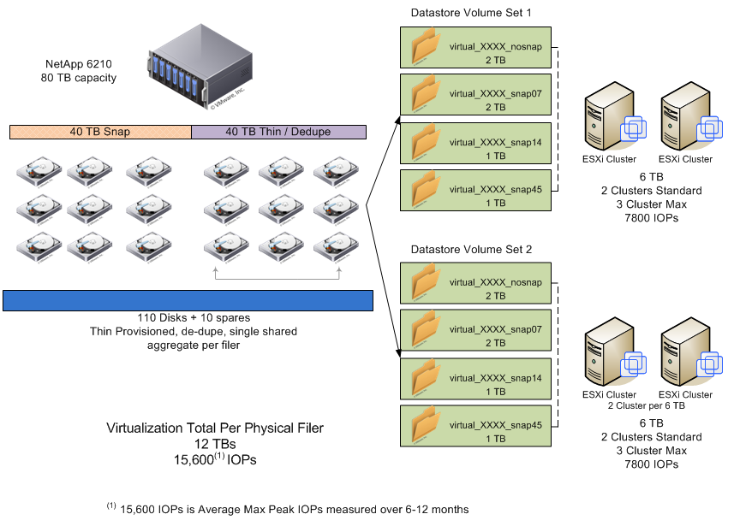
Just to provide some overview the above diagram is given, in general we use single aggregate to allocate the datastores and overall there will be 8 datastores ( 2 set of datastores) and all of them have a standard volume sizes for them,
Datastore name | Total size(GB)
virtual_XXXX_nosnap | 2TB
virtual_XXXX_snap07 | 2TB
virtual_XXXX_snap14 | 1TB
virtual_XXXX_snap45 | 1TB

Using this datastore names we can easily identify whether the datastore needs a backup or not, meaning snapshot is enabled or not. For example , snap07 means 7 days snapshot retention and snap14 means 14 days retention etc..By default all of this 8 datatores will be exported to 4 clusters during provisioning and this can be increased to 3 cluster each ( 3+3 clusters for 8 datastores). This is the standard practice which is being following by VI team.

VM workload overview
In general each filer has its own standard limitations depends on the number of shelves being used. This may vary from filer model to model and also depends on the capability of the storage machine. So it is always recommended to have a one set of standard to run application, DB, VM machines effectively without having any performance issues. When the filer reaches its performance capacity it will start responding slow to the clients, this is one of the indication of filer getting busy and reaching its limit. There are various ways to identify the filer performance capacity usages.
The number of application level 4K I/O operations performed by the system in one second, or IOPs, provides a measure of small Random IO workloads. Small Random Read workloads are extremely disk intensive, and it is important to make sure to avoid disk bottlenecks when sizing volumes for applications that generate this type of I/O. It is important to note that the Random un-cached Read IOPS metric scales linearly until it plateaus as each platforms’ CPU resource limit. For each data disk you add to a volume that will host data for an application that generates small random reads you can expect to get an additional 150 IOPs – up to the around 90-110 or so disks, at which point the filer will again be CPU bound.
Most of the time VM’s will generate more of WRITE IO than READ , which leads to intensive usage of CPU and which is due to the reason underline disks will be busy in handling all the incoming small WRITES makes the CPU to be busy always. This will leads to serious performance issue in a longer run when the number of VM is increased more than the capacity of the filer.
There are various occurrences in our environment which proves the importance of having a standard limits to run the storage environment without issue.

Multiple Datapoints
We used various different data points to derive the number of datastores and number of VM’s per datastore. All the below data (IOPs, Latency, IO size, Write TP,Read TP, Total IOPs, Average IOPS,Total space, used space) are used from the historical data ( 1month,3month,maximum available data) from,
- CPS shared filers
- CPS Dedicated filers
- CIS shared filers
- CIS Dedicated filers

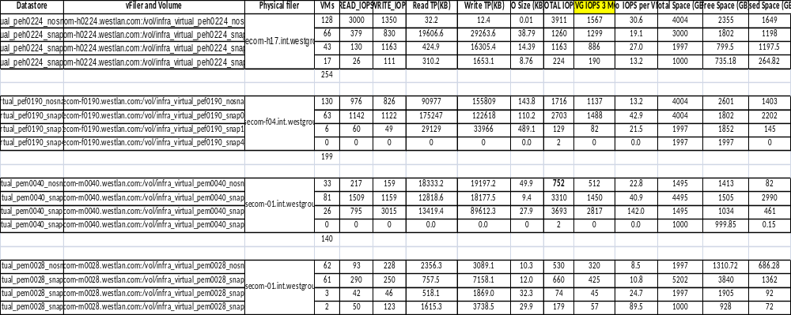
See the attachment for more details,

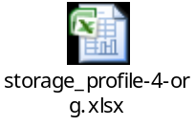

For instance in one of the CPS shared filer (eg-nasecom-h17) one of the datastore sized of 4004GB has nearly 128 VM’s and for this particular model we have estimated IOPs per GB and with that calculation it can handle around 5205 IOPs. So from 128VM’s on this datastore it is expected to consume around 3200 IOPs with a rate of 25 IOPs per VM. On an average for 4004GB volume it can hold nearly 28 to 210 VM’s on this datastore with expectation of 25 IOPs per VM.

Total IOPs | This gives the Average Total peak IOPs for last maximum months (> 6months data)
Avg IOPs 3M | Average IOPs per datastore for last 3months.
No of IOPs per VM | Total average peak IOPs divided by number of VM’s per datastore
Max IOPs per datastore | Total datastore size X IOPs per GB

IMPORTANCE OF IO PROFILING
Before going for the any of the conclusions it will help to understand the importance of the forming this count to make sure the stability of the environment and to avoid any performance issues.

Scenario 1

Issue : One of the Dedicated filer which belongs to TAX had a severe performance issue. Client experienced huge slowness in access the TAX application during the time of tax filing periods (Jan-April).

Mitigation steps : After working with multiple teams ( Windows,VI, network,Antivirus team, Storage team) and having analyzed multiple data,logs from all the ends. Many conference calls being conducted and later finally we found this was more related to the utilization of the storage resources caused this slowness.

Initial VM counts on this filer

C111DVA 159
C111DAQ 79
MN2TRTATP 67
C111EPE 50
CMP111JHU 160
C111AKZ 94
C111NDY 94
C111QJJ 94
C111QKD 94

Load on the filer with above count,

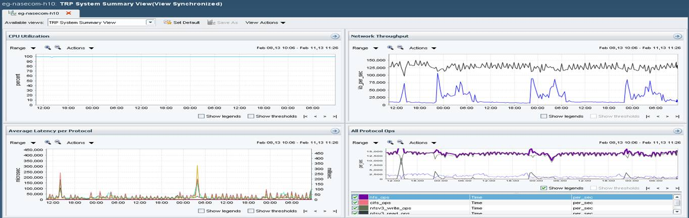

Graph Summary:
- CPU was constantly doing 100%
- Network throughput remains constant as earlier.
- Latency (Read/write ) all remain the same count.
- IOPs utilization remained very high.
Findings:

- As per the calculation what was seen is basically we had a base size of volume : 3400GB for datastore and the IOPs which is expected from this size datastore is about approximately 3400 – 3500 IOPS which is about 1 to 1.5 IOPs per GB. (This is been derived as per disk capability (FCAL disk ).with 15K RPM can provide about 140 -160 IOPs) and again with the RAW usable space in this filer when we count it gives about 1 to 1.5 IOPs per GB) . So on an average of 3400GB it should consume approximately about 3400 – 4500, to the max of 5000 IOPS but in this case it is performing about 13935 IOPs minimum. Which is high, even if we keep 1 IOPs per GB this is deriving to a high limit. The extra space are all used for the processing , WAFL metadata process and VM related process are all been done in the extra space which is one of the reason I think this is been designed as 3400GB as a base volume size .

- As per the calculations it gets an average no of VM’s per datastore is about à 100 – 120 max)
- Average IOPs per VM is derived as à 20 IOPs.

So to answer the below points,

- Total RAW storage allocated to VMs and Non VM workload (in TBs) on H10. Not looking for the VM level information but volume level

- IOPS consumed by VMs and Non VM workloads (average and peaks) on H10

Total IOPS, can be handled by this filer hardware (peak).
No of volumes VM datastores | Total space for VM | No of VM's | Expected IOPs per VM | Current utilization of the VM (IOPS) | Average IOPs by VM's
27 | 10390 | 891 | 12468 | 13935 | 11218
No of non-VM volume | Total space for non-VM |  | Expected IOPs per GB | Current utilization of non-VM (IOPS) | Average IOPs by non-VM
8 | 1434 |  | 2151 to 2200 | 2500-3000 | 2470

Total disks count = 136 (without adding Parity and double parity & spare disks)
Total IOPS expected from this filer = 15,000-17,000 IOPs

Please note above values are approximate ( average) and also the issue in this case is huge WRITE ( 80%) , which will again slow down all the other process. On an average if we have 50% Read and 50% write it can go up to 15k IOPs. But since we have only write is huge which will reduce the overall IOPS and also this filer is running major of VM farms , less non-VM volumes and so, which is one of the reason if we reduce the number of VM’s it will definitely bring down the load on this filer. When cross checked couple of other filers in the same environment which has VM farms they are all works fine with multiple non-VM volumes and are working fine.

Here is the in-depth details , after collecting few more data from storage and could able to find the number of WRITE Vs READ,

Total NFS ops seen: 30773

write: 30488 calls
read: 282 calls
getattr: 2 calls
create: 1 calls

1176 NFS operations for prod-ecom-h0151.clrrs.loc generation 0x440c233d inode 0x01287551
PATH: /vol/infra_c111qkd_vms_nosnap/ds1/c111fbzgrsapp/c111fbzgrsapp_1-flat.vmdk
1176 write operations.

936 NFS operations for prod-ecom-h0151.clrrs.loc generation 0x440c233d inode 0x0118428e
PATH: /vol/infra_c111qkd_vms_nosnap/ds1/c111nftgrsapp/c111nftgrsapp_1-flat.vmdk
98 read operations.
838 write operations.

795 NFS operations for prod-ecom-h0148.clrrs.loc generation 0x416f92ca inode 0x003c9597
PATH: 1
795 write operations.

502 NFS operations for prod-ecom-h0150.clrrs.loc generation 0x427f262b inode 0x013430ae
PATH: /vol/infra_c111qjj_vms_nosnap/ds1/c111htdgrsapp/c111htdgrsapp_1-flat.vmdk
502 write operations.

496 NFS operations for prod-ecom-h0150.clrrs.loc generation 0x427f262b inode 0x01f889ea
PATH: /vol/infra_c111qjj_vms_nosnap/ds1/c111fcagrsapp/c111fcagrsapp_1-flat.vmdk
2 read operations.
494 write operations.

Recommendation from storage Standpoint

All the major one’s are VMDK (VM‘s) which does more than 95% of WRITE and 5% of READ (even less). This is with 7-10 minutes data and when all the VM’s started writing this will push the filer to its upper limit which is what happening here. To reduce the workload further from this filer we need to definitely move few more VM’s which are performing high write to this filer . Hope VM team should be able to find the top talker VM’s and move or distribute them across different filers.

Solution/Fix worked:

VI team moved many VM’s from this physical filer and which reduced the IOPs consumption and also improved the overall performance. This number of VM count was derived by using the above calculation and which matched possible the number of IOPs per VM in a physical filer. After reducing the VM count and matching with the filer capacity level , everything came to normal state and which solved this issue permanently.

No of VM’s count from each datastore :

Eg-nasecom-h10 | 691 (Total)
c111akz | 94
c111ndy | 94
c111qjj | 94
c111qkd | 94
c111daq | 79
c111dva | 88
c111epe | 50
cmp111jhu | 98

Lesson Learned :

Reducing the number of VM and matching with overall filer performance capability fixed the issue.
(more scenarious can be added as on when we have more to be updated here)

BEST PRACTICES

Even though there are various best practices guides available from the respective vendors, they may not be able to cover all the issues or environment needs in one single document. So it is our responsibility to fine tune the environment as per our need and to utilize the existing features effectively. In our environment( CIS/CPS/EX-M) all the VI datastores are accessing the storage VIA NFS protocol and due to the reason the VI is been accessed VIA NFS , the IP based communication happens between the ESX and the storage. The most important things to note is when a data travel from ESX to storage , there are various factors which needs to be considered when planning the performance capability. Even if the storage and ESX cluster able to handle more bandwidth, network may not be, sometime it can be any of the reasons storage,ESX,network. To to give an overview on the connection ,below diagram provides some clarity,

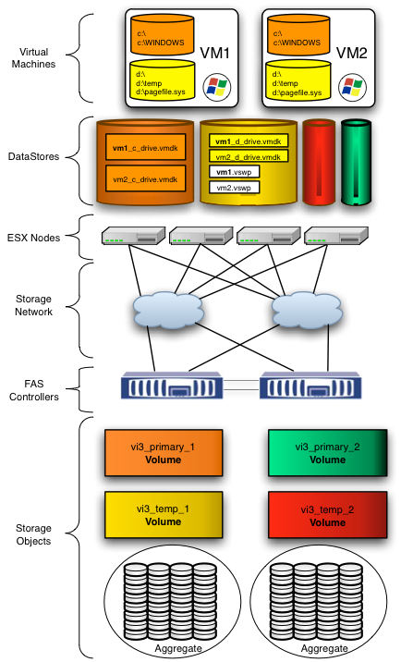

To run a stable and healthy communiation between ESX to storage, make sure to fix all extra IO generating issues like Misaligned IO etc..

- Running without mis-aligned I/O
- Planning limited VM’s per datastore as per the storage capabilities.

Misaligned I/O requires extra work to be performed for both read and write operations. To Satisfy an unaligned read, the controller will need to read at least one extra physical block of data from storage. Satisfying a write operation requires two additional steps that an aligned write does not require.

Misaligned writes may partially overwrite existing data,in which case the storage must preserve the existing data by performing three operations a Read,a Modify and finally the actual Write.It is this read,modify and write set of operations that add overhead and cause unaligned I/O to require additional time to service when compared to aligned I/O.

RECOMMENDATIONS
As per various past experience in our environment, after reducing the VM count performance improved and increased the overall response from the storage end. Since we already have the standard datastore sizes, we can leverage them as it is and are trying to have a limited number of VM’s as per the datastore size. In general IOPs is calculated for per GB, meaning as per the allocated space size the number of expected IOPs is calculated. For example,

For 4004GB of datastore it can handle the workload/IOPs up to 5205 with a calculation as below,

Total allocated space X Design IOPs per GB (as per model) = Expected IOPS

4004GB X 1.3 (6210HT) = 5205 IOPs

This Designed IOPs per GB was derived from multiple tests done from the storage end as per the filer models. Below sheet shows the actual designed IOPS per GB and the expected throughput for each filer model,

Platform Type | Design IOPs per GB | Design Throughput per GB (KB/sec)
3040LT | 0.5 | 6.7
3170HT | 0.8 | 9
6080HT | 0.8 | 9
6080LT | 0.5 | 6.7
6210HT | 1.3 | 18.6
6210LT | 0.5 | 7.5
6220HT | 2.5 | 17.6
2240HT | 0.6 | 17.5

All the above values are derived after running multiple test with various IO sizes. The most commonly used filer models are FAS6080 and FAS6210’s. Most of the cases VM datastore generates more WRITE than READ which reduces the filer performance capabilities and most of the datastore present in the shared filers and so having the number of VM limit is important to match up with the overall filer performance availability to serve other application/DB. As per the standard the datastore sizes are designed as,

Datastore name | Total size(GB)
virtual_XXXX_nosnap | 4004
virtual_XXXX_snap07 | 3000
virtual_XXXX_snap14 | 1997
virtual_XXXX_snap45 | 1000

So with this above volume size and designed IOPs per GB, below approximate values is derived ,

 | Total Space (GB) | Maximum IOPs for Datastore | With 25 IOPs/per VM (Minimum) | With 35 Iops/per VM (Maximum)
 | 4004 | 5205 | 208 | 149
 | 4004 | 5205 | 208 | 149
 | 1997 | 2596 | 104 | 74
 | 1997 | 2596 | 104 | 74
Total | 12002 | 15603 | 624 | 446

After analyzing the existing data, from multiple filers average IOPS per VM came around 35 IOPs per VM (Attached excel sheet above has all the details), with that the maximum count comes around 625 VM per physical filer (with 25 IOPs per VM) and 446 VM per physical filer (with 35IOPs per VM).

From the storage end we can guarantee the total expected IOPS from the complete set (15603 iops) irrespective of any of the volume is underutilized one another. But we wanted to make sure not consuming all available IOPs from the filer. If in case of extra workload is planned in future, VM team can request for more space and which will guarantee certain number of IOPs per allocation.

With all this conditions the final expected count is not more than 520 VM’s in a single physical filer (assuming with above datastore size only).

Total allowed VM’s per datastore set ( 4 volumes) | 520 Vm’s
Total IOPs per VM | 35

Note:

The above recommendation is designed with 20% system CPU headroom for processing and use this as a guidance when provisioning new Datastore in any of the physical filers. The above count may increase or slightly decrease when considering other system process like, Deuplication,disk Scrubs etc..But on an average count should be below this threshold to avoid any performance issues in future.

8.1 Virtualization Storage Big Rules (Draft)

Number of Virtualization Clusters per 4 volume datastore set | 2 Cluster recommended (12 ESXi hosts); 3 Cluster Max (18 ESXi hosts) if IOPs allow.
Max Number of 4 volume datastore sets per physical filer | 2 (8 volumes total) (12 TB)
Max Number of IOPS per 4 volume datastore set | 7800 IOPs ⁽¹⁾ ⁽²⁾
Max Number of Virtual IOPS per physical filer | 15600 IOPs ⁽¹⁾⁽³⁾
Max Number of VM’s per physical filer | 350- 385⁽⁴⁾

- Total Max Average Peak IOPs measured over 6-12 months
- Combination of IOPS across all 4 volumes of datastore set
- Combination of IOPS across all 8 volumes of datastore sets on physical filer
- Based on 35 IOPS/VM avg and 25 IOPS/VM avg
- Considering 15-20% free space and overhead in the datastore it gives 350-385 VM’s.

Challenges needs to be addressed
- Monitoring and alerting of datastore set IOPs as approach thresholds. VI team visibility into storage performance and current IOPs.
- Storage profiles applied to datastore sets or group of 2 datastore sets to allow storage implementation to consider reserved IOPS during provisioning of other workloads on shared filers.
- Availability of sufficient physical filers in each strategic datacenter to adhere to big rules.
- Defined procedure for addressing an ESXi cluster that has remaining compute capacity but is approaching datastore set IOP threshold.
    - Purchase space to increase IOPs
    - Purchase new space and add volumes to cluster(s)
- Filer Cluster mode implications
- Outliers and Non-Standard environment rules
    - Different for Tax
    - How to handle high IO environments where big rules may not work.
- Buy-in from Platform teams, storage teams, management
- On-going validation that real-world operation falls within the observed numbers.
- Periodic review.
- Maintain a standard storage overcommit ratio to avoid losing the space and causing outage.

Even though we have answers or solutions for few of the above questions , it will take some time to manage the capacity of the storage and but will help to improve the stability of the storage by following this big rules, Few FAQ’s,

How to monitor the IOps utilization for per datastore ?
We are trying to leverage the existing monitoring features available from the storage end to alert the VM team if in case any of the datastore goes beyond certain IOPS thresholds. But setting alert fro all datastore is going to be diffecult and but will work with vendor to have something specific for VI volumes.

VM team is also working to set this alerting or monitoring using VCOP(VMware vCenter Orchestrator Plug-in for NetApp) from Netapp.

Also by moving to Netapp Ontap Cluster mode provides more advantage to manage the performance capacity per datastore level and have various other advantages over Ontap 7-Mode.

what happens if we reached this limit ?
If any of the datastore reached its volume size limit, request for more space so that storage support will determine few things before allocating,
- Existing physical filer has space or not
- Whether the existing physical filer has enough room to provide the extra IOPs
Only after the above points didn’t met then VM team needs to request for the new datastore in different filer where all of the above points are met.
(As on when more questions arises will update this document accordingly)

Conclusions
All the above details are derived from the existing data and from the past experience. This document can be changed or modified accordingly to be up to date. There are no assumption details on this document and everything is derived as per the test results and from current environment.

